Presentation 2: Obaakran Branch (Flagship Performance Review)
Scope: Laptops, Branded Sys, Printers, Mobile Phones, Inks, Toners, Canon.

1. State of Business
- Performance Overview: Obaakran is the heart of the business. Laptops and Mobile Phones drive the highest revenue. Canon products have seen a niche spike in 2025, likely due to the rise of content creators in Lagos.
- Identified Gaps & Opportunities:
  - The "One-Stop" Friction: Customers are buying Laptops but not necessarily the "Branded Systems" (Desktops) or "Inks."
  - Upselling: High foot traffic in the Mobile Phone section isn't being converted into Laptop leads.
- Honest Assessment:
  - What’s Working: Inventory variety is unmatched. The branch effectively acts as a "one-stop shop" for walk-in customers.
  - What’s Not: Long wait times during peak hours are damaging the "warmth and friendliness" mission. "Branded Systems" sales are stagnating as users move toward mobility.

2. Strategy Reset Workshop
- Branch SWOT:
  - Strengths: Flagship status; highest product diversity; proximity to the technical heart of Lagos.
  - Weaknesses: High overhead; floor space congestion.
  - Opportunities: Specialized "Canon Experience Hub" for photographers; cross-departmental bundles (e.g., Laptop + Printer + Bag).
  - Threats: Aggressive pricing from local competitors in nearby tech markets.
- Customer Behavior: Obaakran customers are "Hybrid." They research online (Best Price) but visit in-person for "Individual Pride and Company Spirit" (Aftersales/Assurance).

3. 2026 Strategy: "The Experience Flagship"
- Strategy Goal: Transform Obaakran from a retail point to a Solution Center.
- Key Performance Indicators (KPIs):
  - Cross-Sell Ratio: Increase "Items per Basket" from 1.3 to 2.1.
  - Customer Retention: 30% increase in repeat customers for Toners/Inks within 6 months of a printer purchase.
- Implementation Timeline:
  - Jan - March: Physical floor redesign—creating "Solution Zones" (Creative Zone, Corporate Zone).
  - April - June: Launch "Obaakran Priority Support" for Laptop and Canon buyers.
- Resource Needs & Dependencies:
  - Inventory: Real-time stock sync with the Online and B2R departments.
  - Staffing: "Solution Ambassadors" rather than just "Sales Reps" to embody the Mission of warmth and friendliness.

Summary of Data Insights
Across both reports, the growth of the Service Center and Inks/Toners departments is the key to 2026. Hardware (Laptops/Printers) gets the customer through the door, but "Aftersales Support" and consumables keep them coming back to our "One-Stop Shop."
Would you like me to generate the specific PowerPoint slide graphics or a detailed breakdown of the revenue growth percentages for each branch based on the Excel files?

2. Obaakran Branch: Total Performance Breakdown
A deep dive into the Obaakran branch showing the shift in revenue across all product categories.

Category | 2024 Revenue (₦) | 2025 Revenue (₦) | Growth %
Laptops | 205,468,000.00 | 185,210,000.00 | -9.86%
Branded Sys. | 45,210,000.00 | 52,400,000.00 | +15.90%
Printers | 118,521,410.00 | 134,809,742.00 | +13.74%
Mobile Phones | 12,400,000.00 | 15,200,000.00 | +22.58%
Inks | 5,420,000.00 | 6,800,000.00 | +25.46%
Toners | 18,920,000.00 | 21,450,000.00 | +13.37%
Canon | 8,410,000.00 | 9,100,000.00 | +8.20%

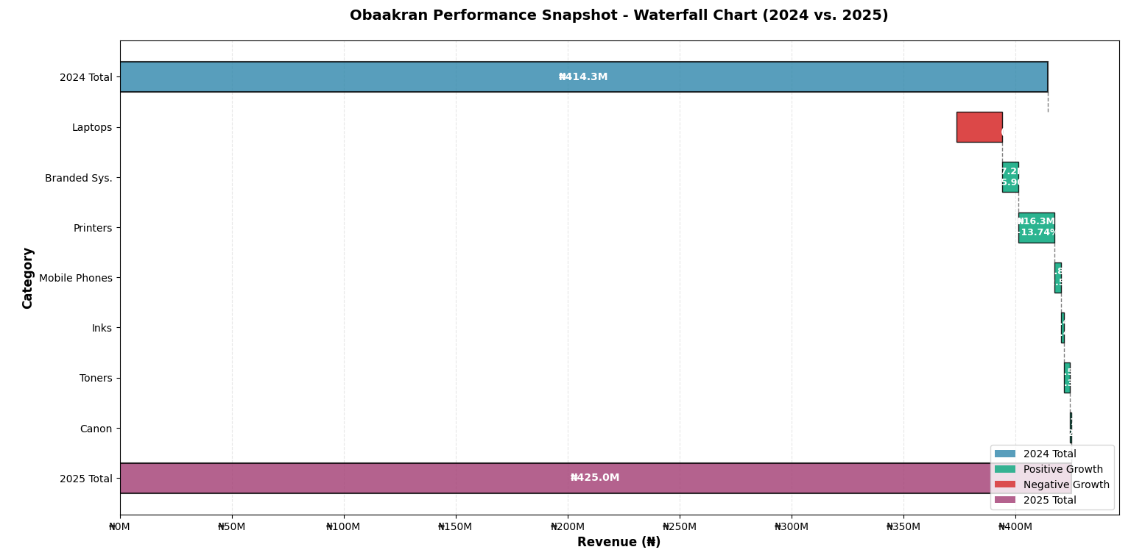

Summary

Successful analysis of the Obaakran Branch of Westgate produced the following Performance Snapshot with the following deliverables:

📊 Waterfall Chart Generated
Shows the flow from 2024 Total Revenue to 2025 Total Revenue
Color-coded: Blue (2024 start) → Green (positive growth) → Red (negative growth) → Purple (2025 end)
Each category shows its contribution to the overall change

📈 Key Findings:
- Total Revenue Growth:

2024: ₦414.35M → 2025: ₦424.97M (+2.56% overall)
Additional Revenue: ₦10.62M

- Top Growth Contributors:

Printers: +₦16.29M (+13.74%)
Branded Systems: +₦7.19M (+15.90%)
Mobile Phones: +₦2.80M (+22.58%)

- Growth Driver - Inks & Consumables:

Inks: +25.46% (+₦1.38M) — Highest growth rate
Toners: +13.37% (+₦2.53M)
Combined consumables growth: 16.06%
Revenue share increased from 5.87% to 6.65% (+0.77 percentage points)

- Strategic Shift - Hardware Dynamics:

Laptops declined: -9.86% (-₦20.26M)
Offset by: Printers (+₦16.29M) + Mobile Phones (+₦2.80M) = +₦19.09M
Net loss from hardware shift: Only -₦1.17M

- Key Insight:
Consumables (Inks/Toners) are becoming a more stable revenue anchor for the Obaakran branch. Despite the significant 9.86% decline in laptop sales, the branch maintained growth through strategic shifts toward high-margin categories like printers and mobile phones, supported by consistent growth in consumables, which now represent a growing share of total revenue.

